Arithmetic Microoperations
The basic Arithmetic Microoperations are addition, subtraction, increment, decrement and shift.
The Arithmetic Microoperation defined by the statement R3 R1+R2 specifies an add microoperation. It states that contents of register R1 are added to the contents of register R2 and sum transferred to register R3.
To implement this statement with hardware we need three registers and the digital component that performs addition operation.
We can specify the subtraction by the following statement:
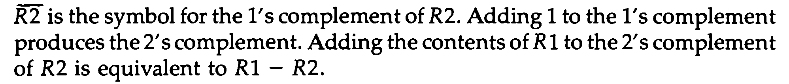
Arithmetic Microoperations
The increment and decrement microoperations are symbolized by plus one and minus-one operations respectively.
In most computers , multiplication operation is implemented with a sequence of add and shift microoperations. Division is implemented with a sequence of subtract and shift microoperations.
Binary Adder
To implement the add microoperation with hardware, we need the registers that hold the data and the digital component that performs the arithmetic addition. The digital circuit that generates the arithmetic sum of two binary numbers of any length is called a binary adder.
The binary adder is constructed with full-adder circuits connected in cascade, with the output carry from one full-adder connected to the input carry of the next full-adder. Figure 4-6 shows the interconnections of four
Example:
0111 (in binary A3A2A1A0) = 7 (decimal)
1111 (in binary B3B2B1B0) = 15 (decimal)
Here C₀=0 because there will be no carry for first two numbers.
Stage | Previous carry | Augends bits A | Addend bits B | Sum | Next carry
0 | C0=0 | A0=1 | B0=1 | S0=0 | C1=1
1 | C1=1 | A1=1 | B1=1 | S1=1 | C2=1
2 | C2=1 | A2=1 | B2=1 | S2=1 | C3=1
3 | C3=1 | A3=0 | B3=1 | S3=0 | C4=1
Sum of two binary numbers from above table is
C4S3S2S1S0 = 10110 (In Binary) = 16+4+2 = 22 ( in decimal)

